**Control Sonoff Devices from Home Assistant**

Home Assistant custom component for control [Sonoff](https://www.itead.cc/) devices with [eWeLink](https://www.ewelink.cc/en/) (original) firmware over LAN and/or Cloud.

**Table of Contents**

* [Main Info](https://github.com/AlexxIT/SonoffLAN#main-info)
* [Tested Devices](https://github.com/AlexxIT/SonoffLAN#tested-devices)
* [Install with HACS](https://github.com/AlexxIT/SonoffLAN#install-with-hacs)
* [Config Examples](https://github.com/AlexxIT/SonoffLAN#config-examples)
  + [Local and Cloud mode](https://github.com/AlexxIT/SonoffLAN#local-and-cloud-mode)
  + [Cloud only mode](https://github.com/AlexxIT/SonoffLAN#cloud-only-mode)
  + [Local mode with load config from Cloud](https://github.com/AlexxIT/SonoffLAN#local-mode-with-load-config-from-cloud)
  + [Local only mode (manual get devicekey)](https://github.com/AlexxIT/SonoffLAN#local-only-mode-manual-get-devicekey)
  + [Local only mode (DIY devices)](https://github.com/AlexxIT/SonoffLAN#local-only-mode-diy-devices)
  + [Custom device_class for any mode](https://github.com/AlexxIT/SonoffLAN#custom-device_class-for-any-mode)
  + [Refresh interval for TH and Pow](https://github.com/AlexxIT/SonoffLAN#refresh-interval-for-th-and-pow)
  + [Sensors from device attributes](https://github.com/AlexxIT/SonoffLAN#sensors-from-device-attributes)
* [Sonoff RF Bridge 433](https://github.com/AlexxIT/SonoffLAN#sonoff-rf-bridge-433)
  + [RF Bridge Sensors](https://github.com/AlexxIT/SonoffLAN#rf-bridge-sensors)
  + [RF Bridge Commands and Events](https://github.com/AlexxIT/SonoffLAN#rf-bridge-commands-and-events)
* [Sonoff Pow Power Consumption](https://github.com/AlexxIT/SonoffLAN#sonoff-pow-power-consumption)
* [Sonoff GK-200MP2-B Camera](https://github.com/AlexxIT/SonoffLAN#sonoff-gk-200mp2-b-camera)
* [Demo](https://github.com/AlexxIT/SonoffLAN#demo)
* [Getting devicekey manually](https://github.com/AlexxIT/SonoffLAN#getting-devicekey-manually)
* [Common problems in only LAN mode](https://github.com/AlexxIT/SonoffLAN#common-problems-in-only-lan-mode)
* [Component Debug Mode](https://github.com/AlexxIT/SonoffLAN#component-debug-mode)
* [Useful Links](https://github.com/AlexxIT/SonoffLAN#useful-links)

**Main Info**

**New features in version 2.0:**

* can manage **both local and cloud control at the same time**!
* support old devices wih 2.7 firmware (only cloud connection)
* support new device types: color lights, sensors, covers
* support eWeLink cameras with PTZ ([read more](https://github.com/AlexxIT/SonoffLAN#sonoff-gk-200mp2-b-camera))
* support unavailable device state for both local and cloud connection
* support refresh interval for Sonoff TH and Sonoff Pow ([read more](https://github.com/AlexxIT/SonoffLAN#refresh-interval-for-th-and-pow))
* support sensors for Sonoff RF Bridge 433 ([read more](https://github.com/AlexxIT/SonoffLAN#rf-bridge-sensors))
* support ZigBee Bridge and Devices
* added new debug mode for troubleshooting ([read more](https://github.com/AlexxIT/SonoffLAN#component-debug-mode))

**Breaking changes 2.0:** by default, both local and cloud modes will start working together. If you do not want this - enable the mode: local setting. But I recommend using the new mode, it works great.

If your internet breaks down - local management will continue to work.  
If you have problems with multicast on the local network - cloud management will work.  
If you want only local or only cloud control - this can also be configured.

[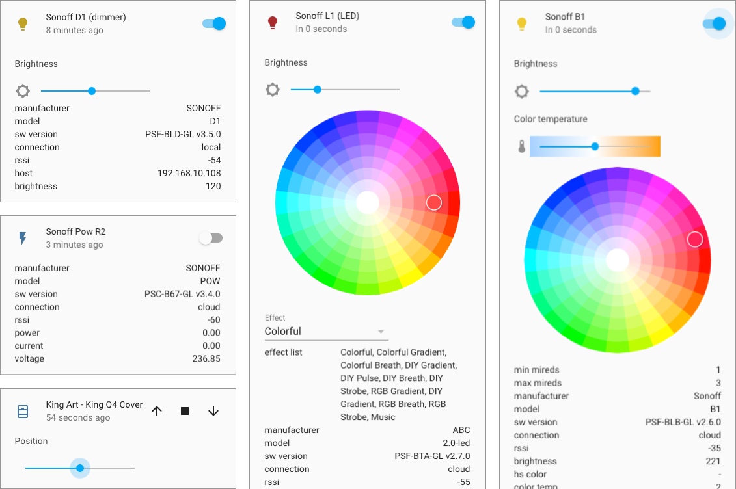](https://github.com/AlexxIT/SonoffLAN/blob/master/demo.png)

Pros:

* work with original eWeLink / Sonoff firmware, no need to flash devices
* work over Local Network and / or Cloud Server ([read more](https://github.com/AlexxIT/SonoffLAN#local-and-cloud-mode))
* work with devices without DIY-mode
* work with devices in DIY-mode ([read more](https://github.com/AlexxIT/SonoffLAN#local-only-mode-diy-devices))
* support single and multi-channel devices
* support TH and Pow device attributes ([read more](https://github.com/AlexxIT/SonoffLAN#sonoff-th-and-pow))
* support Sonoff RF Bridge 433 for receive and send commands ([read more](https://github.com/AlexxIT/SonoffLAN#sonoff-rf-bridge-433))
* support Sonoff GK-200MP2-B Camera ([read more](https://github.com/AlexxIT/SonoffLAN#sonoff-gk-200mp2-b-camera))
* instant device state update with Local Multicast or Cloud Websocket connection
* load devices list from eWeLink Servers (with names, apikey/devicekey and device_class) and save it locally
* (optional) change device type from switch to light ([read more](https://github.com/AlexxIT/SonoffLAN#custom-device_class-for-any-mode))
* (optional) config force refresh interval for TH and Pow ([read more](https://github.com/AlexxIT/SonoffLAN#refresh-interval-for-th-and-pow))

**Component review from DrZzs**

[](https://www.youtube.com/watch?v=DsTqOlrQQ1k)

There is another great component by [@peterbuga](https://github.com/peterbuga/HASS-sonoff-ewelink), that works with cloud servers.

Thanks to [@beveradb](https://github.com/beveradb/sonoff-lan-mode-homeassistant) and [@mattsaxon](https://github.com/mattsaxon/sonoff-lan-mode-homeassistant) for researching the local Sonoff protocol.  
Thanks to [@michthom](https://github.com/michthom) and [@EpicLPer](https://github.com/EpicLPer) for researching the local Sonoff Camera protocol.

**Tested Devices**

**Tested (only LAN)**

Maybe other eWeLink cameras also work, I don’t know.

* [Camera GK-100CD10B](https://www.gearbest.com/smart-home-controls/pp_009678072743.html) (camera with PTZ)
* [Sonoff GK-200MP2-B](https://www.itead.cc/sonoff-gk-200mp2-b-wi-fi-wireless-ip-security-camera.html) (camera with PTZ)

**Tested (LAN and Cloud)**

These devices work both on a local network and through the cloud.

* [Sonoff Basic](https://www.itead.cc/sonoff-wifi-wireless-switch.html) fw 3.0.1
* [Sonoff Basic R2](https://www.itead.cc/sonoff-wifi-wireless-switch-1.html)
* [Sonoff Basic R3](https://www.itead.cc/sonoff-basicr3-wifi-diy-smart-switch.html)
* [Sonoff RFR3](https://www.itead.cc/sonoff-rfr3.html)
* [Sonoff Mini](https://www.itead.cc/sonoff-mini.html) (no need use DIY-mode) fw 3.3.0
* [Sonoff TH](https://www.itead.cc/sonoff-th.html) (show temperature and humidity) fw 3.4.0
* [Sonoff 4CH Pro R2](https://www.itead.cc/sonoff-4ch-pro.html) fw 3.3.0
* [Sonoff 4CH Pro R3](https://www.itead.cc/smart-home/sonoff-4ch-r3-pro-r3.html) fw 3.3.0
* [Sonoff Pow R2](https://www.itead.cc/sonoff-pow-r2.html) (show power consumption)
* [Sonoff Micro](https://www.itead.cc/sonoff-micro-5v-usb-smart-adaptor.html) fw 3.4.0
* [Sonoff RF Bridge 433](https://www.itead.cc/sonoff-rf-bridge-433.html) (receive and send commands) fw 3.3.0, 3.4.0
* [Sonoff D1](https://www.itead.cc/sonoff-d1-smart-dimmer-switch.html) (dimmer with brightness control) fw 3.4.0, 3.5.0
* [Sonoff G1](https://www.itead.cc/sonoff-g1.html) fw 3.5.0
* [Sonoff Dual](https://www.itead.cc/sonoff-dual.html)
* [Sonoff iFan02](https://www.itead.cc/sonoff-ifan02-wifi-smart-ceiling-fan-with-light.html) (light and fan with speed control) fw 3.3.0
* [Sonoff iFan03](https://www.itead.cc/sonoff-ifan03-wifi-ceiling-fan-light-controller.html) (light and fan with speed control) fw 3.4.0
* [Sonoff S20](https://www.itead.cc/smart-socket.html)
* [Sonoff S26](https://www.itead.cc/sonoff-s26-wifi-smart-plug.html)
* [Sonoff S31](https://www.itead.cc/sonoff-s31.html) (show power consumption)
* [Sonoff S55](https://www.itead.cc/sonoff-s55.html)
* [Sonoff SV](https://www.itead.cc/sonoff-sv.html) fw 3.0.1
* [Sonoff T1](https://www.itead.cc/sonoff-t1.html)
* [Sonoff TX](https://www.itead.cc/sonoff-tx-series-wifi-smart-wall-switches.html)
* [Sonoff T4EU1C](https://www.itead.cc/sonoff-t4eu1c-wi-fi-smart-single-wire-wall-switch.html)
* [Sonoff IW100/IW101](https://www.itead.cc/sonoff-iw100-iw101.html)
* [Sonoff Slampher R2](https://www.itead.cc/sonoff-slampher-r2.html)
* [Sonoff 5V DIY](https://www.aliexpress.com/item/32818293817.html)
* [Sonoff RE5V1C](https://www.itead.cc/sonoff-re5v1c.html)
* [MiniTiger Wall Switch](https://www.aliexpress.com/item/33016227381.html) (I have 8 without zero-line) fw 3.3.0
* [Smart Circuit Breaker](https://www.aliexpress.com/item/4000454408211.html)
* [Smart Circuit Breaker](https://www.aliexpress.com/item/4000351300288.html)
* [Smart Circuit Breaker](https://www.aliexpress.com/item/4000077475264.html)
* [Smart Timer Switch](https://www.aliexpress.com/item/4000189016383.html)
* [Eachen WiFi Smart Touch](https://ewelink.eachen.cc/product/eachen-single-live-wall-switch-us-ac-l123ewelink-app/) fw 3.3.0

**Tested (only Cloud)**

These devices only work through the cloud!

* [Sonoff L1](https://www.itead.cc/sonoff-l1-smart-led-light-strip.html) (color, brightness, effects) fw 2.7.0
* [Sonoff B1](https://www.itead.cc/sonoff-b1.html) (color, brightness, color temp) fw 2.6.0
* [Sonoff SC](https://www.itead.cc/sonoff-sc.html) (five sensors) fw 2.7.0
* [Sonoff DW2](https://www.itead.cc/sonoff-dw2.html)
* [King Art - King Q4 Cover](https://www.aliexpress.com/item/32956776611.html) (pause, position) fw 2.7.0
* [KING-M4](https://www.aliexpress.com/item/33013358523.html) (brightness) fw 2.7.0
* [Eachen WiFi Door/Window Sensor](https://ewelink.eachen.cc/product/eachen-wifi-smart-door-window-sensor-wdw-ewelink/)
* [Essential Oils Diffuser](https://www.amazon.co.uk/dp/B07WF7MQ17) (fan and color light) fw 2.9.0
* [Smart USB Mosquito Killer](https://www.aliexpress.com/item/33037963105.html)
* [Smart Bulb RGB+CCT](https://www.aliexpress.com/item/4000764330397.html)

**Tested ZigBee (only Cloud)**

* [Sonoff ZigBee Bridge](https://www.itead.cc/sonoff-zbbridge.html) - turn on for pairing mode
* SONOFF SNZB-01 - Zigbee Wireless Switch
* SONOFF SNZB-02 - ZigBee Temperature and Humidity Sensor
* SONOFF SNZB-03 - ZigBee Motion Sensor
* SONOFF SNZB-04 - ZigBee Wireless door/window sensor

**Install with HACS**

Use [HACS](https://hacs.xyz/) > Integrations > Plus > **SonoffLAN**.

Or manually copy sonoff folder from [latest release](https://github.com/AlexxIT/SonoffLAN/releases/latest) to custom_components folder in your config folder.

**Config Examples**

Cloud mode **cannot work simultaneously** with the 3rd version eWeLink mobile application. You need:

* eWeLink application of the 4th version (Android only)
* create a second account, share devices with it and use it in the component

Cloud mode **cannot work simultaneously** with two copies of component (example main and test Home Assistant). You need:

* create a second account, share devices with it and use it in the second Home Assistant

Local only mode users fine.

Local mode with load device list - break authorization in a mobile application only at the start of Home Assistant.

**Local and Cloud mode**

Recommended for general user.

For devices **on the 3rd firmware version in the same local network with a working multicast**, it uses both local and cloud connections simultaneously.

In other cases, it uses **only a cloud connection**:

* devices on the 2nd firmware version
* devices on another LAN / VLAN
* users with problems setting up multicast traffic
* when the local connection freezes (yes it happens)

sonoff:

username: mymail@gmail.com

password: mypassword

or

sonoff:

username: +910123456789 # important to use country code

password: mypassword

If you have Sonoff Pow or Sonoff TH, you might want to use this kind of config:

sonoff:

username: mymail@gmail.com

password: mypassword

force_update: [temperature, power]

scan_interval: '00:05:00' # (optional) default 5 minutes

sensors: [temperature, humidity, power, current, voltage]

Read below what it means.

**Cloud only mode**

Recommended for users with a bad router, which may freeze due to multicast traffic.

sonoff:

username: mymail@gmail.com

password: mypassword

mode: cloud

**Local mode with load config from Cloud**

Legacy mode. Only downloads a list of devices from Cloud Servers. Works with local protocol. Only works with devices on 3rd firmware.

sonoff:

username: mymail@gmail.com

password: mypassword

mode: local

reload: always # update device list every time HA starts

Component loads list of devices from eWeLink Servers and save it in the file /config/.sonoff.json (hidden file).

The list will be loaded only once. At the next start, the list will be loaded from the local file. When you have new **eWeLink** devices - manually delete the file and reboot the HA.

With reload: always in the config - the list will be loaded from servers at each start.

The list will be loaded from the local file even if you remove username and password from the settings.

**Local only mode (manual get devicekey)**

I don’t understand who needs it, but you never know. You must manually get devicekey for each device. Only works with devices on 3rd firmware.

sonoff:

devices:

1000abcdefg:

devicekey: f9765c85-463a-4623-9cbe-8d59266cb2e4

See [Getting devicekey manually](https://github.com/AlexxIT/SonoffLAN#getting-devicekey-manually) to retrieve the devicekey.

**Local only mode (DIY devices)**

Recommended for users who do not trust Cloud Servers for some reason. Only works with devices in DIY mode.

sonoff:

**Custom device_class for any mode**

You can convert all switches into light by default:

sonoff:

default_class: light # (optional), default switch

You can convert specific switches into lights or fans:

sonoff:

devices:

1000abcde0:

device_class: light

name: Sonoff Basic

1000abcde1:

device_class: fan

name: Sonoff Mini

You can convert multi-channel devices (e.g. Sonoff T1 2C):

sonoff:

devices:

1000abcde2:

device_class: [light, fan]

name: Sonoff T1 2C

1000abcde3:

device_class: [light, light]

name: MiniTiger 2CH

You can convert multi-channel device (e.g. Sonoff T1 3C) into single light with brightness control:

sonoff:

devices:

1000abcde4:

device_class:

- light: [1, 2, 3]

name: Sonoff T1 3C

You can control multiple light zones with single multi-channel device (e.g. Sonoff 4CH Pow):

sonoff:

devices:

1000abcde5:

device_class:

- light # zone 1 (channel 1)

- light # zone 2 (channel 2)

- light: [3, 4] # zone 3 (channels 3 and 4)

name: Sonoff 4CH Pow

You can change device_class for Door Sensor:

sonoff:

devices:

1000abcde6:

device_class: window

You can skip importing any cloud devices:

sonoff:

devices:

1000abcde7:

device_class: exclude

**Refresh interval for TH and Pow**

You can config forced updating of TH and Pow attributes ([read more](https://github.com/AlexxIT/SonoffLAN/issues/14)).

**Force update device by attribute**

It is not necessary to list all the attributes of each device (e.g. temperature and humidity). Only one is enough.

sonoff:

force_update: [temperature, power]

scan_interval: '00:05:00' # (optional) default 5 minutes

**Force update device by deviceid**

sonoff:

scan_interval: '00:05:00' # (optional) default 5 minutes

devices:

1000abcde0:

name: Sonoff TH

force_update: True

1000abcde1:

name: Sonoff Pow

force_update: True

**Sensors from device attributes**

Temperature and power sensors are not created by default!  
You can list all the attributes you want to see as sensors.

sonoff:

sensors: [temperature, humidity, power, current, voltage, rssi]

**Sonoff RF Bridge 433**

**Video HOWTO from @KPeyanski**

[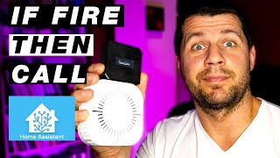](https://www.youtube.com/watch?v=QD1K7s01cak?t=284)

Video HOWTO from me in [Demo](https://github.com/AlexxIT/SonoffLAN#demo) section.

**RF Bridge Sensors**

You can config sensors for your RF Bridge.

The PIR sensor sends a signal if it detects motion. The door / window sensor sends a signal when open. You can set the time after which the sensor goes into off state. Default 120 seconds.

If you has door sensor with two states (for open and for closed state) like [this one](https://www.banggood.com/10Pcs-GS-WDS07-Wireless-Door-Magnetic-Strip-433MHz-for-Security-Alarm-Home-System-p-1597356.html?cur_warehouse=CN), you can config payload_off as in the example below. Also disable the timeout if you do not need it in this case (with timeout: 0 option).

You can use any device_class that is supported in [Binary Sensor](https://www.home-assistant.io/integrations/binary_sensor/).

**PIR Sensor**

sonoff:

rfbridge:

PIR Sensor 1: # sensor name in eWeLink application

device_class: motion

timeout: 60 # optional (default 120), timeout in seconds for auto turn off

PIR Sensor 2: # sensor name in eWeLink application

device_class: motion

timeout: 60 # optional (default 120), timeout in seconds for auto turn off

**Single State Sensor**

sonoff:

rfbridge:

Door Sensor 1: # sensor name in eWeLink application

name: Door Sensor # optional, you can change sensor name

device_class: door # e.g. door, window

timeout: 5

Door Sensor 2:

name: Door Sensor

device_class: door

timeout: 5

**Dual State Sensor**

sonoff:

rfbridge:

Button1: # button name in eWeLink application (open signal)

name: Window Sensor # optional, you can change sensor name

device_class: window # e.g. door, window

timeout: 0 # disable auto close timeout

payload_off: Button2 # button name in eWeLink application (close signal)

Button3:

name: Window Sensor

device_class: window

timeout: 0

payload_off: Button4

**RF Bridge Commands and Events**

Component will create only one entity per RF Bridge - remote.sonoff_1000abcdefg.

You can receive signals from RF Buttons and RF Sensors through an event sonoff.remote. And send signals using the service remote.send_command.

Although the component supports training, it is recommended to train RF Buttons through the eWeLink application.

When a command is received, the event sonoff.remote is generated with a button number and response time (in UTC, sends the device).

The last command received can be seen in the Bridge attributes:

](https://github.com/AlexxIT/SonoffLAN/blob/master/demo_bridge.png)

**Example for receive all RF signal**

automation:

- alias: Sonoff RF Receive

trigger:

platform: event

event_type: sonoff.remote # this is NOT entity_id, don't change it!

action:

service: persistent_notification.create

data_template:

title: Sonoff RF Receive

message: |-

Name: {{ trigger.event.data.name }}

Command: {{ trigger.event.data.command }}

Time: {{ trigger.event.data.ts }}

**Example of reaction to the selected button**

Instead of a name: Button1, you can use command: 0 number of the button in the eWeLink application (starts from zero).

automation:

- alias: Receive Button1

trigger:

platform: event

event_type: sonoff.remote # this is NOT entity_id, don't change it!

event_data:

name: Button1 # button/sensor name in eWeLink application

action:

service: persistent_notification.create

data:

message: My Remote button pressed

**Example for send RF signal**

script:

send_button1:

alias: Send RF Button1

sequence:

- service: remote.send_command

data:

entity_id: remote.sonoff_1000abcdef

command: Button1 # button name in eWeLink application

**Sonoff Pow Power Consumption**

For update power consumption of all your Pow devices you can call sonoff.update_consumption service.

The device attributes will display data for the last 100 days. The first element is today's data. It's up to you how often to call updates and what to do with this data later.

Remember, without calling the service, there will be no values. Use automation.

sensor:

- platform: template

sensors:

today_consumption:

friendly_name: Today consumpion

unit_of_measurement: kWh

value_template: "{{ state_attr('switch.sonoff_1000abcdef', 'consumption').0 }}"

ten_days_consumption:

friendly_name: 10 days consumpion

unit_of_measurement: kWh

value_template: "{% set p=state_attr('switch.sonoff_1000abcdef', 'consumption') %}{{ p[:10]|sum if p }}"

**Sonoff GK-200MP2-B Camera**

Currently only PTZ commands are supported. Camera entity is not created now.

You can send left, right, up, down commands with sonoff.send_command service:

script:

left:

sequence:

- service: sonoff.send_command

data:

device: '012345' # use quotes, this is important

cmd: left

device - this is the number from the camera ID EWLK-012345-XXXXX, exactly 6 digits (leading zeros - it is important).

**Never ever tell anyone your camera ID!**

*In development: camera entity with still image and stream support.*

**Demo**

Check other videos on my [YouTube](https://www.youtube.com/c/AlexxIT) channel.

**Sonoff RF Bridge automation via Node-RED**

[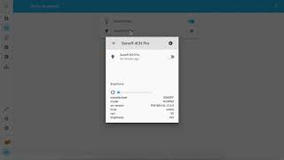](https://www.youtube.com/watch?v=DhYIjEOtZ_I)

**Control Sonoff 4CH Pow R2 from HomeKit**

[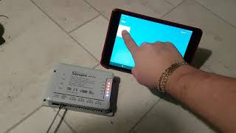](https://www.youtube.com/watch?v=X7PcYfDy57A) [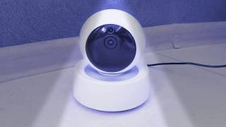](https://www.youtube.com/watch?v=TnFS7qWgKoo)

Change **Name** or **Entity ID** of any device:

](https://github.com/AlexxIT/SonoffLAN/blob/master/demo_rename.gif)

**Getting devicekey manually**

1. Put the device in setup mode
2. Connect to the Wi-Fi network ITEAD-10000, password 12345678
3. Open in browser http://10.10.7.1/device
4. Copy deviceid and apikey (this is devicekey)
5. Connect to your Wi-Fi network and setup Sonoff via the eWeLink app

**For Sonoff Micro**

The process above does not work for the Sonoff Micro (USB Smart Adapter). Use [Local mode with load config from Cloud](https://github.com/AlexxIT/SonoffLAN#local-mode-with-load-config-from-cloud).

**Common problems in only LAN mode**

Cloud users don't have these problems.

**Devices are not displayed**

1. Only supported devices with firmware v3+
2. Common problems with Multicast:
   * two routers
   * **docker** with port forwarding
     + you must use: [--network host](https://docs.docker.com/network/network-tutorial-host/)
     + hassio users are okay
   * **virtual machine** with port forwarding
     + you must use bridge virtual network mode (not NAT mode)
   * Oracle VM VirtualBox
   * linux firewall
   * linux network driver
   * incorrect network interface selected in HA Configuration -> Settings -> Global -> Network

The devices publish their data through [Multicast DNS](https://en.wikipedia.org/wiki/Multicast_DNS) (mDNS/[zeroconf](https://www.home-assistant.io/integrations/zeroconf/)), read [more](http://developers.sonoff.tech/sonoff-diy-mode-api-protocol.html#Device-mDNS-Service-Info-Publish-Process).

**Devices unavailable after reboot**

All devices **unavailable** after each Home Assistant restart. It does not depend on reload setting. Devices are automatically detected in the local network after each restart. Sometimes devices appear quickly. Sometimes after a few minutes. If this does not happen, there are some problems with the multicast / router.

**Component Debug Mode**

Component support debug mode. Shows only component logs and removes all private data automatically. The link to the logs is always random.

[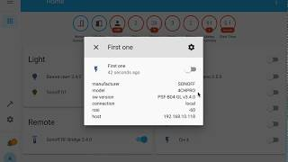](https://www.youtube.com/watch?v=Lt5fT4N5Pm8)

sonoff:

username: mymail@gmail.com

password: mypassword

debug: True # you will get HA notification with a link to the logs page

You can filter multiple devices in the logs and enable auto refresh (in seconds).

http://192.168.1.123:8123/c4e99cfc-0c83-4a39-b7f0-278b0e719bd1?q=1000abcde1|1000abcde2&r=2

All unknown devices with command switch support will be added as switch.

All other unknown devices will be added as binary_sensor (always off). The full state of the device is displayed in its attributes.

The component adds the service sonoff.send_command to send low-level commands.

Example service params to single switch:

device: 1000123456

switch: 'on'

Example service params to multi-channel switch:

device: 1000123456

switches: [{outlet: 0, switch: 'off'}]

Example service params to dimmer:

device: 1000123456

cmd: dimmable

switch: 'on'

brightness: 50

mode: 0

**Useful Links**

* <https://github.com/peterbuga/HASS-sonoff-ewelink>
* <https://github.com/beveradb/sonoff-lan-mode-homeassistant>
* <https://github.com/mattsaxon/sonoff-lan-mode-homeassistant>
* <https://github.com/EpicLPer/Sonoff_GK-200MP2-B_Dump>
* <https://blog.ipsumdomus.com/sonoff-switch-complete-hack-without-firmware-upgrade-1b2d6632c01>
* <https://github.com/itead/Sonoff_Devices_DIY_Tools/blob/master/SONOFF%20DIY%20MODE%20Protocol%20Doc%20v1.4.md>
* [SONOFF DIY MODE API PROTOCOL](http://developers.sonoff.tech/sonoff-diy-mode-api-protocol.html)
* [No Tasmota And EWeLink Cloud To Control The SONOFF Device? YES!](https://sonoff.tech/product-tutorials/diy-mode-to-control-the-sonoff-device)